Control and organize Azure resources with Azure Resource Manager

Use Azure Resource Manager to organize resources, enforce standards, and protect critical assets from deletion.
- Use resource groups to organize Azure resources
- Use tags to organize resources
- Apply policies to enforce standards in your Azure environments
- Use resource locks to protect critical Azure resources from accidental deletion

What are resource groups?
Resource groups are a fundamental element of the Azure platform. A resource group is a logical container for resources deployed on Azure. These resources are anything you create in an Azure subscription like virtual machines, Application Gateways, and CosmosDB instances. All resources must be in a resource group and a resource can only be a member of a single resource group.

Logical grouping
Resource groups exist to help manage and organize your Azure resources. By placing resources of similar usage, type, or location, you can provide some order and organization to resources you create in Azure. Logical grouping is the aspect that you're most interested in here, since there's a lot of disorder among our resources.
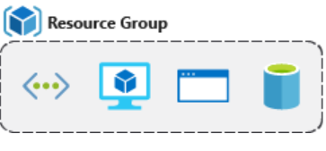

Authorization
Resource groups are also a scope for applying role-based access control (RBAC) permissions. By applying RBAC permissions to a resource group, you can ease administration and limit access to allow only what is needed.
You can start with using an understandable naming convention. You named our resource group msftlearn-core-infrastructure-rg. You've given some indication of what it's used for (msftlearn), the types of resources contained within (core-infrastructure), and the type of resource it is itself (rg).

Organizing principles
Resource groups can be organized in a number of ways, let's take a look at a few examples. You might put all resources that are core infrastructure into this resource group. But you could also organize them strictly by resource type. For example, put all virtual networks in one resource group, all virtual machines in another resource group, and all Azure Cosmos DB instances in yet another resource group.
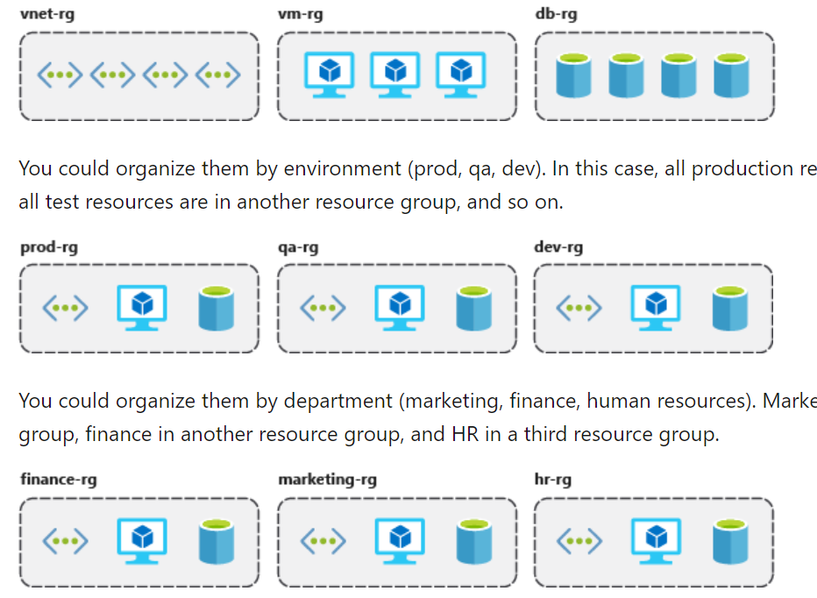

Organizing for authorization

Organizing for life cycle

Organizing for billing

Use tagging to organize resources

What are tags?
Tags are name/value pairs of text data that you can apply to resources and resource groups. Tags allow you to associate custom details about your resource, in addition to the standard Azure properties a resource has the following properties:
- department (like finance, marketing, and more)
- environment (prod, test, dev)
- cost center
- life cycle and automation (like shutdown and startup of virtual machines)

az resource tag --tags Department=Finance \
--resource-group msftlearn-core-infrastructure-rg \
--name msftlearn-vnet1 \
--resource-type "Microsoft.Network/virtualNetworks"
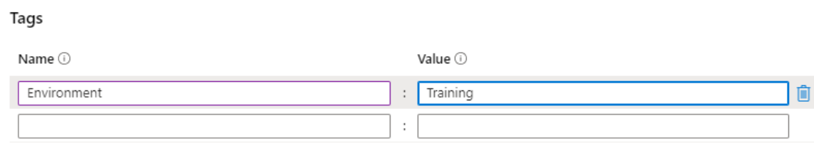

Use policies to enforce standards

What is Azure Policy?
Azure Policy is a service you can use to create, assign, and manage policies. These policies apply and enforce rules that your resources need to follow. These policies can enforce these rules when resources are created, and can be evaluated against existing resources to give visibility into compliance.
Policies can enforce things such as only allowing specific types of resources to be created, or only allowing resources in specific Azure regions. You can enforce naming conventions across your Azure environment. You can also enforce that specific tags are applied to resources. You'll take a look at how policies work.

Create a policy
You'd like to ensure that all resources have the Department tag associated with them and block creation if it doesn't exist.
Navigate to the Azure portal in a web browser if you haven't already. In the search box in the top navigation bar, search for Policy and select the Policy service.
For the Policy rule, delete all text in the box and paste in the following JSON.
{
"mode": "Indexed",
"policyRule": {
"if": {
"field": "[concat('tags[', parameters('tagName'), ']')]",
"exists": "false"
},
"then": {
"effect": "deny"
}
},
"parameters": {
"tagName": {
"type": "String",
"metadata": {
"displayName": "Tag Name",
"description": "Name of the tag, such as 'environment'"
}
}
}
}

Create a policy assignment
You've created the policy, but you haven't actually put it into effect yet. To enable the policy, you need to create an assignment. In this case, you'll assign it to the scope of your msftlearn-core-infrastructure-rg resource group, so that it applies to anything inside the resource group.

Secure resources with role-based access control

Using RBAC, you can:
- Allow one user to manage VMs in a subscription, and another user to manage virtual networks.
- Allow a database administrator (DBA) group to manage SQL databases in a subscription.
- Allow a user to manage all resources in a resource group, such as VMs, websites, and virtual subnets.
- Allow an application to access all resources in a resource group.

Best Practices for RBAC
Here are some best practices you should use when setting up resources.
- Segregate duties within your team and grant only the amount of access to users that they need to perform their jobs. Instead of giving everybody unrestricted permissions in your Azure subscription or resources, allow only specific actions at a particular scope.
- When planning your access control strategy, grant users the lowest privilege level that they need to do their work.
- Use Resource Locks to ensure critical resources aren't modified or deleted (as you'll see in the next unit).

Use resource locks to protect resources

What are resource locks?
Resource locks are a setting that can be applied to any resource to block modification or deletion. Resource locks can set to either Delete or Read-only. Delete will allow all operations against the resource but block the ability to delete it. Read-only will only allow read activities to be performed against it, blocking any modification or deletion of the resource. Resource locks can be applied to subscriptions, resource groups, and to individual resources, and are inherited when applied at higher levels.

Use resource locks in practice
You've seen how resource locks can protect from accidental deletion. To delete the virtual network, you needed to remove the lock. This concerted action helps ensure that you really intend to delete or modify the resource in question.
These are applied at the resource group level

Move Azure resources to another resource group

Identify them with Tags

Check the limitations on resource types
After identifying the resource types of your resources, you must investigate whether they can be moved, and the restrictions that might be in place. Check your resource types against the move support for resources list. The list shows whether each resource type can be moved between resource groups or between subscriptions. For example, these resources can be moved:
- Azure Storage accounts
- Azure virtual machines
- Azure virtual networks
These resources can't be moved:
- Azure Active Directory domain services
- Azure Backup vaults
- Azure App Service gateways
Virtual machines have their own limitations you must keep in mind. Here's a summary of limitations for virtual machines:
- If you want to move a virtual machine, all of its dependants must go with it.
- You can't move virtual machines with certificates in Azure Key Vault between subscriptions.
- You can't move virtual machine scale sets with standard load balancers or a standard public IP.
- You can't move any managed disks that are in availability zones to different subscriptions.
Consider all the relevant limitations before attempting to move your resources. You can then decide which resources are candidates for a move.

Validate resources in Azure
In this unit, you'll learn how to validate that a move would be successful. You'll also see how to use the Azure REST API validate move operation to test and validate your moves.

Prepare to test your move
Before attempting to move a resource, you can test whether it will be successful by calling the validate move operation from the Azure REST API. This test is especially useful if you're trying to move resources by using, for example, Azure PowerShell or the Azure CLI. You can use these tools to script moves, with minimal human interaction. Testing a move doesn't affect your resources. The operation only tests whether your move operation would succeed, based on the options you provide.
If you're trying to move resources through the Azure portal, you don't need to validate the move before attempting it. The Azure portal does an automatic validation before allowing you to move resources.
POST https://management.azure.com/subscriptions/<your-subscription-id>/resourceGroups/<your-source-group>/validateMoveResources?api-version=2019-05-10
Authorization: Bearer <your-access-token>
Content-type: application/json
{
"resources": ["<your-resource-id-1>", "<your-resource-id-2>", "<your-resource-id-3>"],
"targetResourceGroup": "/subscriptions/<your-subscription-id>/resourceGroups/<your-target-group>"
}

az rest --method post \
--uri https://management.azure.com/subscriptions/{subscriptionId}/resourceGroups/<your-source-group>/validateMoveResources?api-version=2019-05-10 \
--body "{\"resources\": [\"<your-resource-id-1>\", \"<your-resource-id-2>\", \"<your-resource-id-3>\"], \"targetResourceGroup\": \"/subscriptions/<your-subscription-id>/resourceGroups/<your-target-group>\"}" \
--verbose

Move resources between subscriptions
Depending on the resource type, you can move your resources between subscriptions, or between resource groups within the same subscription.
For our scenario, we just need to move a pair of storage accounts to a different resource group within the same subscription. If, for billing reasons, we needed to move something like an Azure web app and all its dependent resources under a different subscription, that might include more steps. As mentioned in unit 2, you'd need to move all dependent resources into one resource group. Then, you can move those resources into a new resource group under a different subscription. The following diagram shows the steps you might need to take. This example includes a resource with one dependent resource in a separate resource group.
Get the resource.
yourResource=$(az resource show --resource-group <resource group name> --name <resource name> --resource-type <resource type> --query id --output tsv)
Move the resource to another resource group by using the resource ID.
az resource move --destination-group <destination resource group name> --ids $yourResource

Deploy a website to Azure with Azure App Service

Host a web application with Azure App Service

Hosting your web application using Azure App Service makes deploying and managing a web app much easier when compared to managing a physical server.

What is Azure App Service
Azure App Service is a fully managed web application hosting platform. This platform as a service (PaaS) offered by Azure allows you to focus on designing and building your app while Azure takes care of the infrastructure to run and scale your applications.

Deployment slots
Using the Azure portal, you can easily add deployment slots to an App Service web app. For instance, you can create a staging deployment slot where you can push your code to test on Azure. Once you are happy with your code, you can easily swap the staging deployment slot with the production slot. You do all this with a few simple mouse clicks in the Azure portal.

Continuous integration/deployment support
The Azure portal provides out-of-the-box continuous integration and deployment with Azure DevOps, GitHub, Bitbucket, FTP, or a local Git repository on your development machine. Connect your web app with any of the above sources and App Service will do the rest for you by automatically syncing your code and any future changes on the code into the web app. Furthermore, with Azure DevOps, you can define your own build and release process that compiles your source code, runs the tests, builds a release, and finally deploys the release into your web app every time you commit the code. All that happens implicitly without any need to intervene.
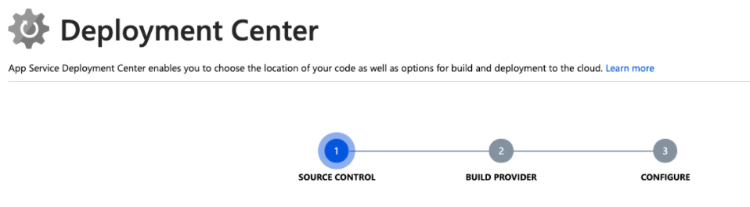

Integrated Visual Studio publishing and FTP publishing

Built-in auto scale support (automatic scale-out based on real-world load)
Baked into the web app is the ability to scale up/down or scale out. Depending on the usage of the web app, you can scale your app up/down by increasing/decreasing the resources of the underlying machine that is hosting your web app. Resources can be number of cores or the amount of RAM available.

Creating a web app
Field | Description
Subscription | A valid and active Azure subscription.
Resource group | A valid resource group.
App name | The name of the web app. This name becomes part of the app's URL, so it must be unique among all Azure App Service web apps.
Publish | You can deploy your application to App Service as code or as a ready-to-run Docker image. Selecting Docker image will activate the Docker tab of the wizard, where you provide information about the Docker registry from which App Service will retrieve your image.
Runtime stack | If you choose to deploy your application as code, App Service needs to know what runtime your application uses (examples include Node.js, Python, Java, and .NET). If you deploy your application as a Docker image, you will not need to choose a runtime stack, since your image will include it.
Operating system | App Service can host applications on Windows or Linux servers. See below for additional information.
Region | The Azure region from which your application will be served.
App Service Plan | See below for information about App Service plans.

App Service plans
An App Service plan is a set of virtual server resources that run App Service apps. A plan's size (sometimes referred to as its sku or pricing tier) determines the performance characteristics of the virtual servers that run the apps assigned to the plan and the App Service features that those apps have access to. Every App Service web app you create must be assigned to a single App Service plan that runs it.
A single App Service plan can host multiple App Service web apps. In most cases, the number of apps you can run on a single plan will be limited by the performance characteristics of the apps and the resource limitations of the plan.
App Service plans are the unit of billing for App Service. The size of each App Service plan in your subscription, in addition to the bandwidth resources used by the apps deployed to those plans, determines the price that you pay. The number of web apps deployed to your App Service plans has no effect on your bill.
You can use any of the available Azure management tools to create an App Service plan. When you create a web app via the Azure portal, the wizard will help you to create a new plan at the same time if you don't already have one.

Automated deployment
Automated deployment, or continuous integration, is a process used to push out new features and bug fixes in a fast and repetitive pattern with minimal impact on end users.
Azure supports automated deployment directly from several sources. The following options are available:
- Azure DevOps: You can push your code to Azure DevOps (previously known as Visual Studio Team Services), build your code in the cloud, run the tests, generate a release from the code, and finally, push your code to an Azure Web App.
- GitHub: Azure supports automated deployment directly from GitHub. When you connect your GitHub repository to Azure for automated deployment, any changes you push to your production branch on GitHub will be automatically deployed for you.
- Bitbucket: With its similarities to GitHub, you can configure an automated deployment with Bitbucket.
- OneDrive: Microsoft's cloud-based storage. You must have a Microsoft Account linked to a OneDrive account to deploy to Azure.
- Dropbox: Azure supports deployment from Dropbox, which is a popular cloud-based storage system that is similar to OneDrive.

Manual deployment
There are a few options that you can use to manually push your code to Azure:
- Git: App Service web apps feature a Git URL that you can add as a remote repository. Pushing to the remote repository will deploy your app.
- az webapp up: webapp up is a feature of the az command-line interface that packages your app and deploys it. Unlike other deployment methods, az webapp up can create a new App Service web app for you if you haven't already created one.
- ZIP deploy: Use az webapp deployment source config-zip to send a ZIP of your application files to App Service. ZIP deploy can also be accessed via basic HTTP utilities such as curl.
- WAR deploy: It's an App Service deployment mechanism specifically designed for deploying Java web applications using WAR packages. WAR deploy can be accessed using the Kudu HTTP API located at http://<your-app-name>.scm.azurewebsites.net/api/wardeploy. If this fails try: https://<your-app-name>.scm.azurewebsites.net/api/wardeploy.
- Visual Studio: Visual Studio features an App Service deployment wizard that can walk you through the deployment process.
- FTP/S: FTP or FTPS is a traditional way of pushing your code to many hosting environments, including App Service.

az webapp deployment source config-zip \
--src site.zip \
--resource-group [sandbox resource group name] \
--name <your-app-name>

Stage a web app deployment for testing and rollback by using App Service deployment slots

Use deployment slots to streamline deployment and roll back a web app in Azure App Service.
You want a way to deploy a new version of the app without downtime or a service interruption. You also want to be able to rapidly roll back a new deployment to the previous version if it causes problems.
- Create a deployment slot as a staging environment in App Service.
- Use git to deploy a new version of a web app to a slot.
- Configure which app settings are swapped and which are not swapped when you deploy a slot.
- Swap slots to deploy a web app or roll back a deployment.

Use a deployment slot
Within a single Azure App Service web app, you can create multiple deployment slots. Each slot is a separate instance of that web app, and it has a separate hostname. You can deploy a different version of your web app into each slot.
One slot is the production slot. This slot is the web app that users see when they connect. Make sure that the app deployed to this slot is stable and well tested.

Understand slots as separate Azure resources
When you use more than one deployment slot for a web app, those slots are treated as separate instances of that web app. For example, they're listed separately on the All resources page in the Azure portal. They each have their own URL. However, each slot shares the resources of the App Service plan, including virtual machine memory and CPU as well as disk space.
Deployment slots are available only when your web app uses an App Service plan in the Standard, Premium, or Isolated tier.

Create a deployment slot
Before you create a slot, make sure your web app is running in the Standard, Premium, or Isolated tier:
- Open your web app in the Azure portal.
- Select the Deployment Slots page.
- Select Add Slot.
- Name the slot.
- Choose whether to clone settings from another slot. If you choose to clone, settings are copied to your new slot from the slot you specify.
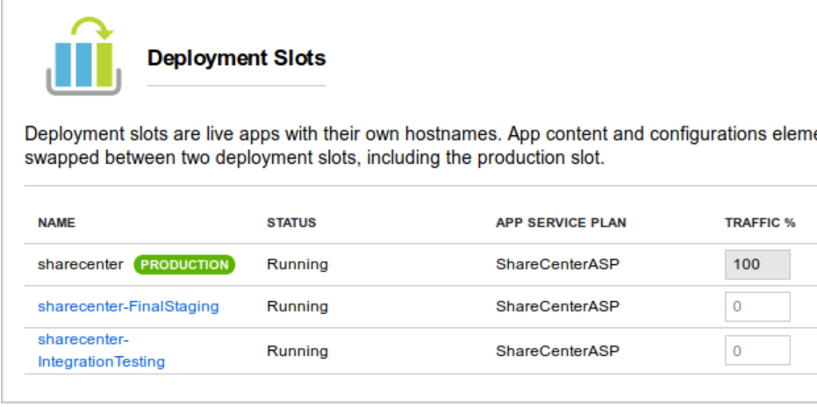
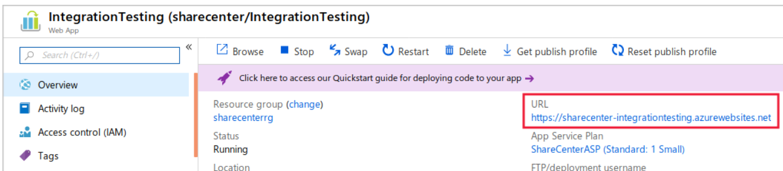

You can deploy your code to the new slot the same way you deploy it for the production slot. Just substitute the new slot's name or URL in the configuration of the deployment tool you use. If you use FTP to deploy, you'll see the FTP hostname and username just under the slot's URL.

When you swap two slots, the app's configuration travels to the new slot along with the app. You can override this behavior for individual application settings and configuration strings by configuring them as slot settings.

Configure slot settings

On the Application settings tab, observe whether the settings you're interested in contain a checkmark in the deployment slot setting field. To set or unset a checkmark on a given setting, select the setting's pencil button to edit it, then toggle the deployment slot setting checkbox to the desired value, and select OK.

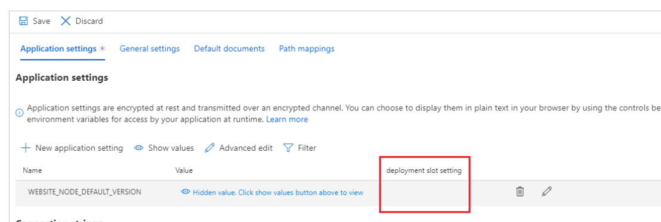
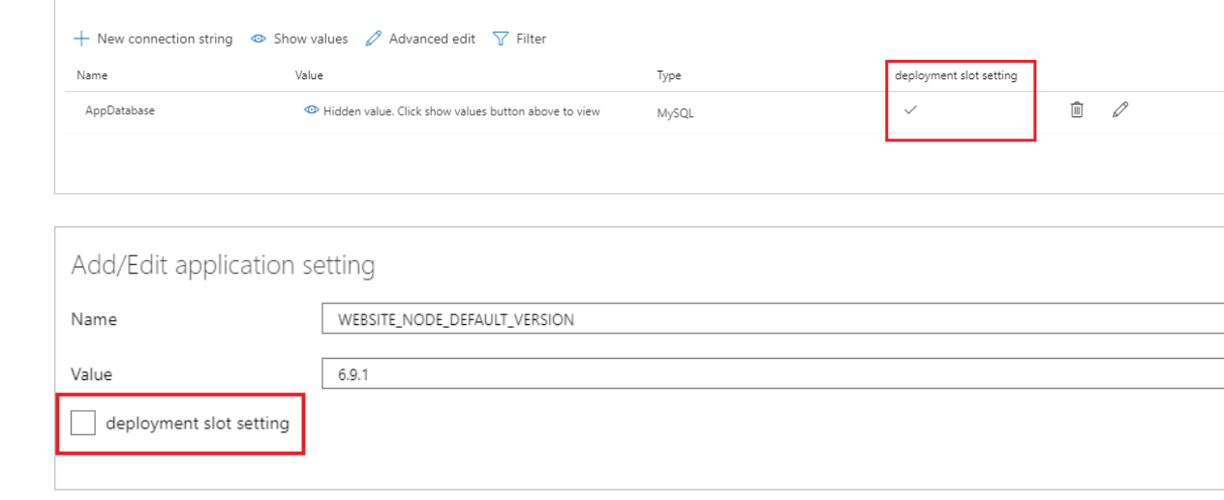

Swap slots in the Azure portal
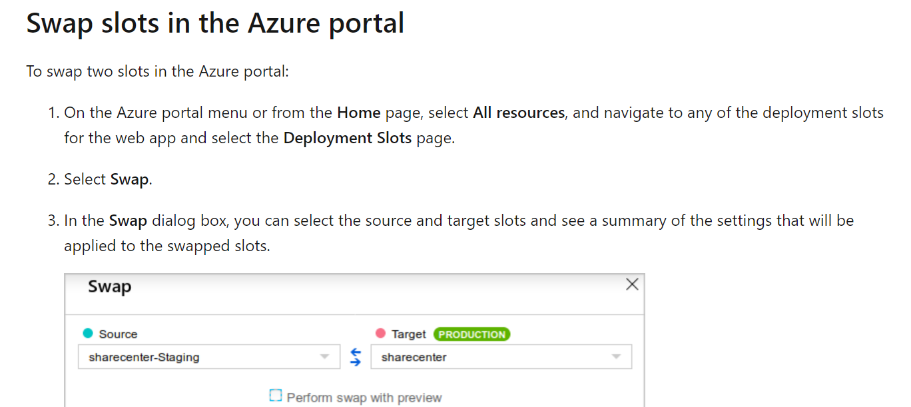
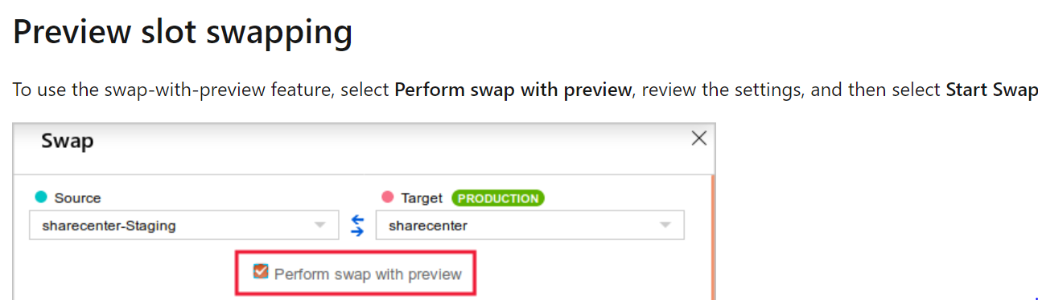

Auto swap
Auto swap brings the zero-downtime and easy rollback benefits of swap-based deployment to automated deployment pipelines. When you configure a slot for auto swap, Azure automatically swaps it whenever you push code or content into that slot.

Configure auto swap
To configure auto swap for a slot, navigate to the Configuration > General settings pane for the slot in the Azure portal. Under Deployment Slot, set Auto swap enabled to On, select the target slot from the dropdown menu, and then select Save at the top.
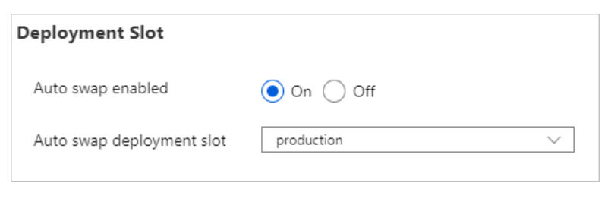

Configure auto swap for the staging slot
Suppose that now that you're using deployment slots, you want to enable continuous deployment. You'll do this by using the auto swap feature for your web app. In a system that uses auto swap, when you deploy new code to the staging slot, Azure automatically warms it up and deploys it to production by swapping the staging and production slots. To configure auto swap, follow these steps:
- Go to the Configuration page of the staging slot's web app, and navigate to the General settings tab.
- Set Auto swap enabled to On.
- In the Auto swap deployment slot list, select production, and then select Save.

Roll back the new version
Suppose that deploying version 3 of your app to production revealed an unexpected problem. To quickly resolve it, you can roll back to the previous version of the site by swapping the slots again.

Scale an App Service web app to efficiently meet demand with App Service scale up and scale out

It's important to be able to scale a web app for these reasons:
- It enables the app to remain responsive during periods of high demand.
- It helps to save you money by reducing the resources required when demand drops.

Monitor and scale a web app
When you create a web app, you can either create a new App Service plan or use an existing one. If you select an existing plan, any other web apps that use the same plan will share resources with your web app. They'll all scale together, so they need to have the same scaling requirements. If your apps have different requirements, use a separate App Service plan for each one.
The key to scaling effectively is knowing when to scale, and by how much. You monitor the performance of a web app by using the metrics available for the App Service. The simplest way to do this is to use the Azure portal. If you notice a steady increase in resource use, such as CPU utilization, memory occupancy, or disk queue length, you should consider scaling out before these metrics hit a critical point. You should also monitor the average response time of requests and the number of failing requests. If both of these figures are high, the system might be running close to (or beyond) capacity. You might need to scale out immediately.
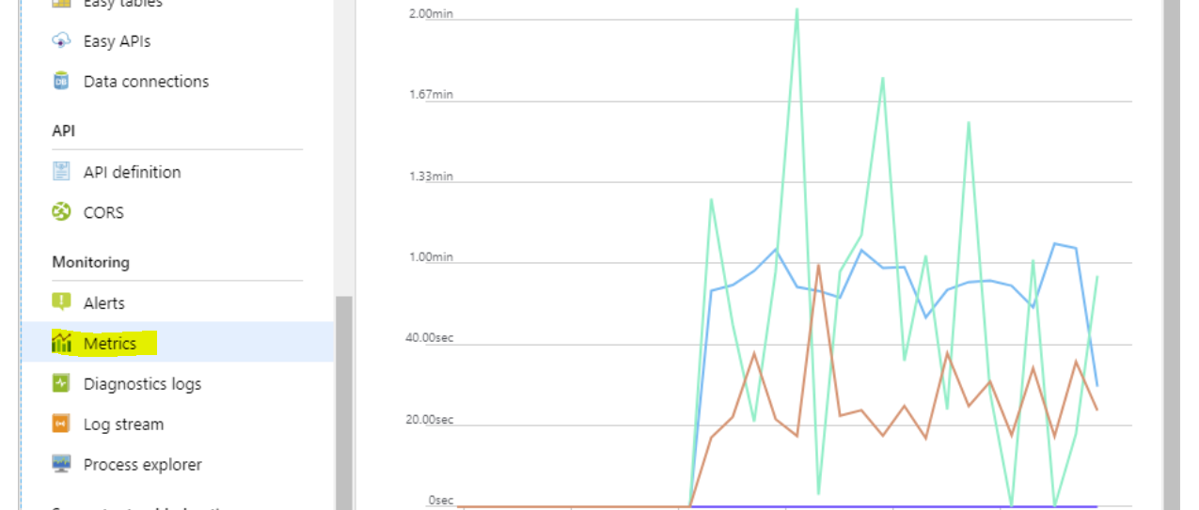
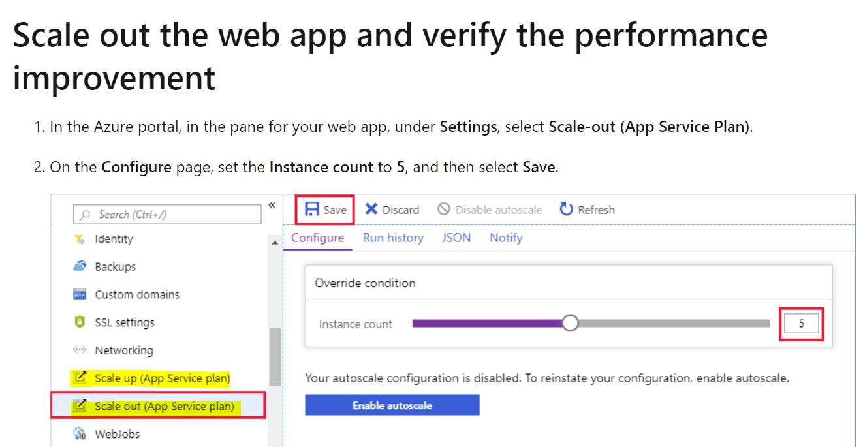
Scaling out enables you to run more instances of a web app, but the resources available to each instance are determined by the pricing tier used by the App Service plan that hosts the web service
But the resources might become too limited if demand for your web service grows, or if you add features that require more power. In this case, you can scale up to a more powerful pricing tier.
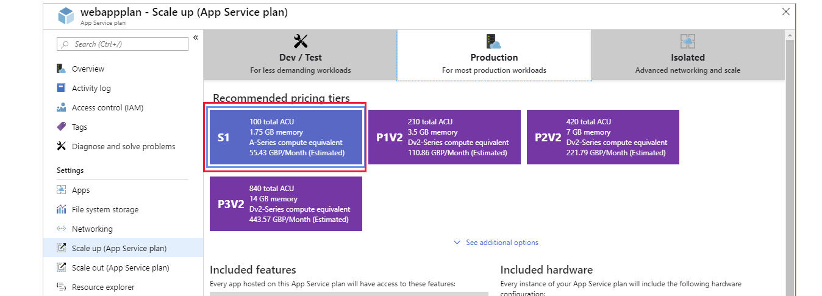

Deploy and run a containerized web app with Azure App Service

Build and store images by using Azure Container Registry

Azure Container Registry enables you to store Docker images in the cloud, in an Azure storage account.

What is Container Registry?
Container Registry is an Azure service that you can use to create your own private Docker registries. Like Docker Hub, Container Registry is organized around repositories that contain one or more images. Container Registry also lets you automate tasks such as redeploying an app when an image is rebuilt.
Security is an important reason to choose Container Registry instead of Docker Hub:
- You have much more control over who can see and use your images.
- You can sign images to increase trust and reduce the chances of an image becoming accidentally (or intentionally) corrupted or otherwise infected.
- All images stored in a container registry are encrypted at rest.
Working with images in Container Registry is like working with Docker Hub, but offers a few unique benefits:
- Container Registry runs in Azure. The registry can be replicated to store images near where they're likely to be deployed.
- Container Registry is highly scalable, providing enhanced throughput for Docker pulls that can span many nodes concurrently. The Premium SKU of Container Registry includes 500 GiB of storage.
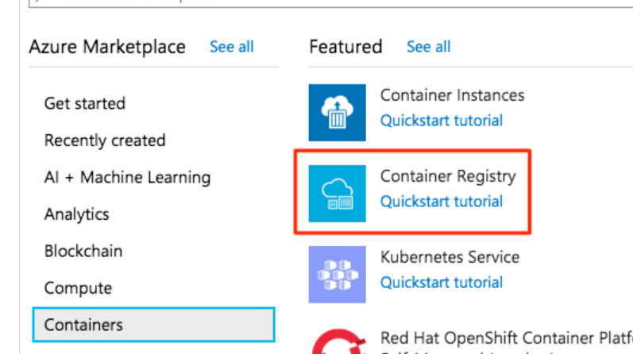
Run the following command. This command sends the folder's contents to Azure Container Registry, which uses the instructions in the Docker file to build the image and store it. Replace <container_registry_name> with the name of the registry you created earlier. Take care not to leave out the . character at the end of the command.
az acr build --registry <container_registry_name> --image webimage .

Deploy a web app from a repository in Azure Container Registry
When you create a web app from a Docker image, you configure the following properties:
- Registry that contains the image: The registry can be Docker Hub, Azure Container Registry, or some other private registry.
- Image: This item is the name of the repository.
- Tag: This item indicates which version of the image to use from the repository. By convention, the most recent version is given the tag latest when it's built.
- Startup file: This item is the name of an executable file or a command to be run when the image is loaded. It's equivalent to the command that you can supply to Docker when running an image from the command line by using docker run. If you're deploying a ready-to-run, containerized app that already has the ENTRYPOINT and/or COMMAND values configured, you don't need to fill this in.

Enable Docker access to the Azure Container Registry (ACR)
You'll use Docker to login to the registry and pull the web image that you want to deploy. Docker needs a username and password to perform this action. The ACR allows you to enable the registry name as the username and admin access key as the password to allow Docker to login to your container registry.
- Sign in to the Azure portal, and go to All resources.
- Select the container registry you created earlier to navigate to the Overview page for the container registry.
- In the left menu pane, under Settings, select Access keys.
- Set the Admin user option to Enable. This change saves automatically.
You're now ready to create your web app.

Update the image and automatically redeploy the web app

What is a webhook?
Azure App Service supports continuous deployment using webhooks. A webhook is a service offered by Azure Container Registry. Services and applications can subscribe to the webhook to receive notifications about updates to images in the registry. A web app that uses App Service can subscribe to an Azure Container Registry webhook to receive notifications about updates to the image that contains the web app. When the image is updated, and App Service receives a notification, your app automatically restarts the site and pulls the latest version of the image.

What is the Container Registry tasks feature?
You use the tasks feature of Container Registry to rebuild your image whenever its source code changes automatically. You configure a Container Registry task to monitor the GitHub repository that contains your code and trigger a build each time it changes. If the build finishes successfully, Container Registry can store the image in the repository. If your web app is set up for continuous integration in App Service, it receives a notification via the webhook and updates the app.
Let's use these two features to enable continuous integration from the App Service.

Enable continuous integration from App Service
The Container settings page of an App Service resource in the Azure portal automates the setup of continuous integration. If you turn on Continuous Deployment, App Service configures a webhook in your container registry to notify an App Service endpoint. Notifications from the registry that reach this endpoint cause your app to restart and pull the latest version of the container image.

Extend continuous integration to source control by using a Container Registry task
az acr task create --registry <container_registry_name> --name buildwebapp --image webimage --context https://github.com/MicrosoftDocs/mslearn-deploy-run-container-app-service.git --file Dockerfile --git-access-token <access_token>

Secure your cloud data

After completing this module, you'll be able to:
- Strengthen your security posture and protect against threats by using Azure Security Center.
- Collect and act on security data from many different sources by using Azure Sentinel.
- Store and access sensitive information such as passwords and encryption keys securely in Azure Key Vault.
- Manage dedicated physical servers to host your Azure VMs for Windows and Linux by using Azure Dedicated Host.

Protect against security threats by using Azure Security Center

Security Center can:
- Monitor security settings across on-premises and cloud workloads.
- Automatically apply required security settings to new resources as they come online.
- Provide security recommendations that are based on your current configurations, resources, and networks.
- Continuously monitor your resources and perform automatic security assessments to identify potential vulnerabilities before those vulnerabilities can be exploited.
- Use machine learning to detect and block malware from being installed on your virtual machines (VMs) and other resources. You can also use adaptive application controls to define rules that list allowed applications to ensure that only applications you allow can run.
- Detect and analyze potential inbound attacks and investigate threats and any post-breach activity that might have occurred.
- Provide just-in-time access control for network ports. Doing so reduces your attack surface by ensuring that the network only allows traffic that you require at the time that you need it to.
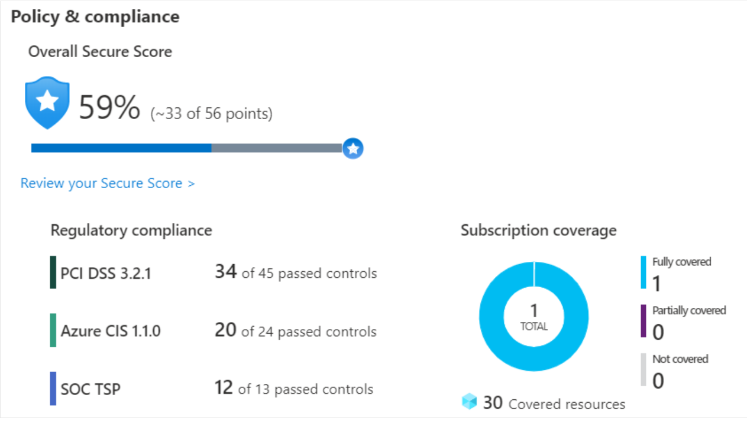

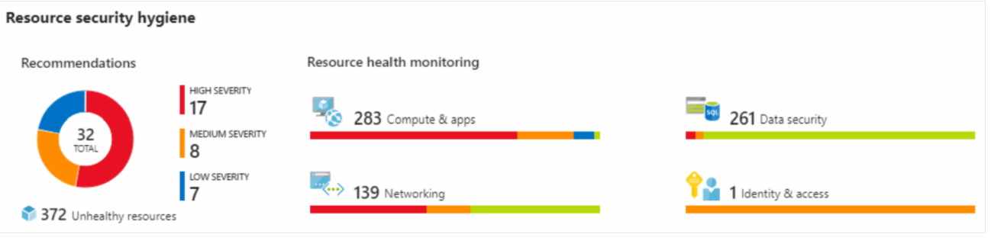

What's secure score?
Secure score is a measurement of an organization's security posture.
Secure score is based on security controls, or groups of related security recommendations. Your score is based on the percentage of security controls that you satisfy. The more security controls you satisfy, the higher the score you receive. Your score improves when you remediate all of the recommendations for a single resource within a control.

Protect against threats
Security Center includes advanced cloud defense capabilities for VMs, network security, and file integrity. Let's look at how some of these capabilities apply to Tailwind Traders.
- Just-in-time VM access
Tailwind Traders will configure just-in-time access to VMs. This access blocks traffic by default to specific network ports of VMs, but allows traffic for a specified time when an admin requests and approves it.
- Adaptive application controls
Tailwind Traders can control which applications are allowed to run on its VMs. In the background, Security Center uses machine learning to look at the processes running on a VM. It creates exception rules for each resource group that holds the VMs and provides recommendations. This process provides alerts that inform the company about unauthorized applications that are running on its VMs.
- Adaptive network hardening
Security Center can monitor the internet traffic patterns of the VMs, and compare those patterns with the company's current network security group (NSG) settings. From there, Security Center can make recommendations about whether the NSGs should be locked down further and provide remediation steps.
- File integrity monitoring
Tailwind Traders can also configure the monitoring of changes to important files on both Windows and Linux, registry settings, applications, and other aspects that might indicate a security attack.

Respond to security alerts
Tailwind Traders can use Security Center to get a centralized view of all of its security alerts. From there, the company can dismiss false alerts, investigate them further, remediate alerts manually, or use an automated response with a workflow automation.

Detect and respond to security threats by using Azure Sentinel

Azure Sentinel capabilities
Azure Sentinel enables you to:
- Collect cloud data at scale
Collect data across all users, devices, applications, and infrastructure, both on-premises and from multiple clouds.
- Detect previously undetected threats
Minimize false positives by using Microsoft's comprehensive analytics and threat intelligence.
- Investigate threats with artificial intelligence
Examine suspicious activities at scale, tapping into years of cybersecurity experience from Microsoft.
- Respond to incidents rapidly
Use built-in orchestration and automation of common tasks.

Connect your data sources
Tailwind Traders decides to explore the capabilities of Azure Sentinel. First, the company identifies and connects its data sources.
Azure Sentinel supports a number of data sources, which it can analyze for security events. These connections are handled by built-in connectors or industry-standard log formats and APIs.
- Connect Microsoft solutions
- Connect other services and solutions
- Connect industry-standard data sources

Azure Sentinel supports a number of data sources, which it can analyze for security events. These connections are handled by built-in connectors or industry-standard log formats and APIs.
- Connect Microsoft solutions
Connectors provide real-time integration for services like Microsoft Threat Protection solutions, Microsoft 365 sources (including Office 365), Azure Active Directory, and Windows Defender Firewall.
- Connect other services and solutions
Connectors are available for common non-Microsoft services and solutions, including AWS CloudTrail, Citrix Analytics (Security), Sophos XG Firewall, VMware Carbon Black Cloud, and Okta SSO.
- Connect industry-standard data sources
Azure Sentinel supports data from other sources that use the Common Event Format (CEF) messaging standard, Syslog, or REST API.

Detect threats
Tailwind Traders needs to be notified when something suspicious occurs. It decides to use both built-in analytics and custom rules to detect threats.
Built in analytics use templates designed by Microsoft's team of security experts and analysts based on known threats, common attack vectors, and escalation chains for suspicious activity. These templates can be customized and search across the environment for any activity that looks suspicious. Some templates use machine learning behavioral analytics that are based on Microsoft proprietary algorithms.
Custom analytics are rules that you create to search for specific criteria within your environment. You can preview the number of results that the query would generate (based on past log events) and set a schedule for the query to run. You can also set an alert threshold.

Investigate and respond
When Azure Sentinel detects suspicious events, Tailwind Traders can investigate specific alerts or incidents (a group of related alerts). With the investigation graph, the company can review information from entities directly connected to the alert, and see common exploration queries to help guide the investigation.
Here's an example that shows what an investigation graph looks like in Azure Sentinel.

The company will also use Azure Monitor Workbooks to automate responses to threats. For example, it can set an alert that looks for malicious IP addresses that access the network and create a workbook that does the following steps:
- When the alert is triggered, open a ticket in the IT ticketing system.
- Send a message to the security operations channel in Microsoft Teams or Slack to make sure the security analysts are aware of the incident.
- Send all of the information in the alert to the senior network admin and to the security admin. The email message includes two user option buttons: Block or Ignore.
When an admin chooses Block, the IP address is blocked in the firewall, and the user is disabled in Azure Active Directory. When an admin chooses Ignore, the alert is closed in Azure Sentinel, and the incident is closed in the IT ticketing system.

What can Azure Key Vault do?
Azure Key Vault can help you:
- Manage secrets
You can use Key Vault to securely store and tightly control access to tokens, passwords, certificates, API keys, and other secrets.
- Manage encryption keys
You can use Key Vault as a key management solution. Key Vault makes it easier to create and control the encryption keys that are used to encrypt your data.
- Manage SSL/TLS certificates
Key Vault enables you to provision, manage, and deploy your public and private Secure Sockets Layer/Transport Layer Security (SSL/TLS) certificates for both your Azure resources and your internal resources.
- Store secrets backed by hardware security modules (HSMs)
These secrets and keys can be protected either by software or by FIPS 140-2 Level 2 validated HSMs.

What are the benefits of Azure Key Vault?
The benefits of using Key Vault include:
- Centralized application secrets
Centralizing the storage for your application secrets enables you to control their distribution, and reduces the chances that secrets are accidentally leaked.
- Securely stored secrets and keys
Azure uses industry-standard algorithms, key lengths, and HSMs. Access to Key Vault requires proper authentication and authorization.
- Access monitoring and access control
By using Key Vault, you can monitor and control access to your application secrets.
- Simplified administration of application secrets
Key Vault makes it easier to enroll and renew certificates from public certificate authorities (CAs). You can also scale up and replicate content within regions and use standard certificate management tools.
- Integration with other Azure services
You can integrate Key Vault with storage accounts, container registries, event hubs, and many more Azure services. These services can then securely reference the secrets stored in Key Vault.
Show Password
az keyvault secret show \
--name MyPassword \
--vault-name <my-keyvault-NNN> \
--query value \
--output tsv
Some organizations must follow regulatory compliance that requires them to be the only customer using the physical machine that hosts their virtual machines. Azure Dedicated Host provides dedicated physical servers to host your Azure VMs for Windows and Linux.
Azure Dedicated Host:
- Gives you visibility into, and control over, the server infrastructure that's running your Azure VMs.
- Helps address compliance requirements by deploying your workloads on an isolated server.
- Lets you choose the number of processors, server capabilities, VM series, and VM sizes within the same host.

